**Press release**

Palsgaard starts major expansion of Netherlands factory to double PGPR production

***New CEO Helle Müller Petersen officiates at ground-breaking ceremony***

9th February 2023

Palsgaard has started work on a major expansion at its specialist Netherlands factory for high-grade PGPR emulsifiers.

PGPR (polyglycerol polyricinoleate) is a co-emulsifier primarily used in chocolate production to control flow, reduce viscosity and optimize moulding and enrobing. It also reduces fat content in margarine spreads and is a highly effective, plant-based colour-dispersing aid that replaces petrol-based waxes in plastics.

Scheduled for completion in 2024, the €18 million expansion to Palsgaard’s Netherlands plant, which also makes specialty ingredients for margarine and bakery, will double the company’s global capacity to produce PGPR, demand for which is growing by 10% per year.

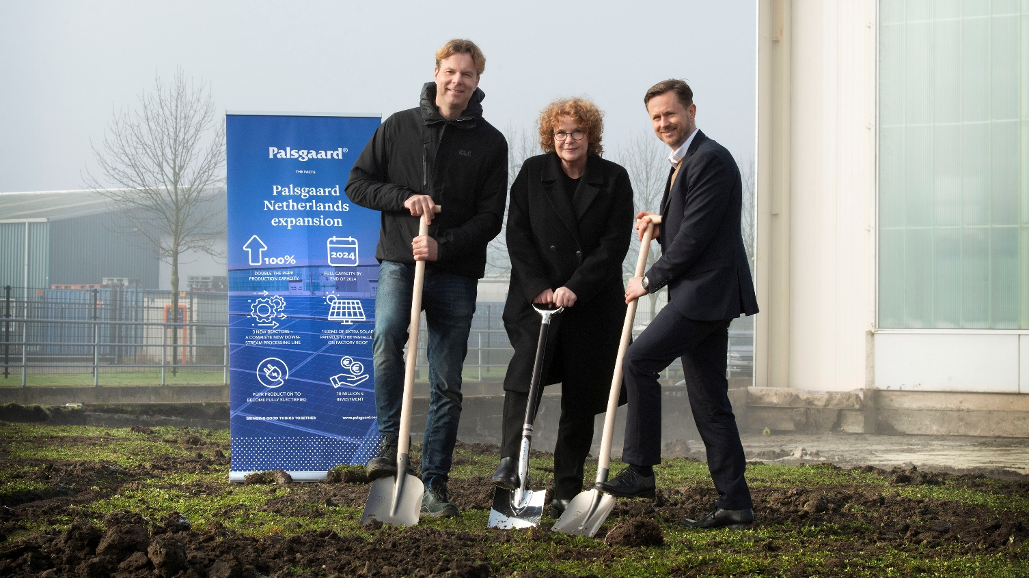

*Palsgaard Netherlands Site Director Joris Dhont (left), new Palsgaard CEO Helle Müller Petersen and CCO Kim Bøjstrup breaks ground for expanding the PGPR factory. The €18 million investment will double the factory's capacity to 11500 MT annually by 2024.*

The facility achieved CO2-neutral production (Scope 1 and 2) status in 2018. The energy-saving design of the new extension includes an additional 1500m2 of solar panels and complete electrification of PGPR production, along with three new reactors and a new downstream processing line.

Palsgaard Netherlands Site Director Joris Dhont said: “As well as almost doubling our PGPR capacity to 11500 MT annually, this expansion will substantially increase storage capacity for raw materials and finished goods, which will secure business continuity in times of supply chain disruptions.”

Palsgaard’s new Chief Executive Officer Helle Müller Petersen, who recently joined the company from Arla Foods, led the ground-breaking ceremony on 7th February. She commented: “Visiting our facilities around the world and meeting Palsgaard employees is a priority for my first 100 days as CEO, so seeing work start on the PGPR factory extension in the Netherlands has been a great opportunity to learn more about Palsgaard’s unique DNA.”

Chief Operations Officer Kim Bøjstrup, who also participated in the ceremony, added: “We are already market leaders in PGPR and the world’s only commercial source of fully sustainable emulsifiers. Our expanded Netherlands plant will continue to manufacture the highest quality, palm-free PGPR products.”

Palsgaard is also investing heavily in its main production site in Denmark and is currently installing a new 30,000 MT spray cooling tower. This facility will be supported by the construction of multiple new reaction, distillation, and esterification plants. The €125 million investment will double its production capacity by 2024.

**For more information, contact:**

Mette Dal Steffensen, Global Brand Communications Manager, Palsgaard A/S  
[mds@palsgaard.dk](mailto:mds@palsgaard.dk) | +45 2073 4534

**About Palsgaard**

Palsgaard is the world’s only full-service emulsifier and stabiliser company. It offers sustainably produced, customer-tailored solutions for the global food industry, as well as non-food markets such as polymers and personal care.

Emulsifiers and stabilisers allow otherwise incompatible ingredients to be combined, creating exciting new capabilities and functionality. This enables manufacturers of bakery, confectionery, condiments, dairy, ice cream, margarine and plant-based products to improve their quality, taste, mouthfeel, texture and shelf-life, and to create better-for-you foods with leaner labels, less fat and better nutritional value, while using fewer resources.

Since founder Einar Viggo Schou invented the modern plant-based food emulsifier in 1917, Palsgaard has offered expertise and innovation. From its six application centres around the world, its experienced food technologists help manufacturers optimize existing recipes and develop delicious products with superior nutritional profiles.

Palsgaard enables manufacturers to meet consumer and regulatory demands for greater responsibility, helping them grow and protect their brands. It is the world’s only commercial source of fully sustainable emulsifiers based on RSPO SG-certified palm oil and produced by CO2-neutral factories (scope 1 and 2) in Denmark, the Netherlands, Mexico, Brazil, China and Malaysia. All products are non-GMO and meet halal and kosher requirements.

The company’s emulsifiers are dual-use and also serve as plant-based polymer additives, which are rapidly emerging as highly effective, sustainable alternatives to conventional oil-based additives. They offer anti-static performance to prevent dust-attraction, helping to make food packaging more appealing, as well as anti-fog performance, which helps to control water condensation, extend shelf-life and reduce food waste.

Palsgaard is owned by the Schou Foundation and has 690+ employees across 18 countries. Its turnover in 2022 was 343 million USD (2.4 billion DKK), with products sold to more than 120 countries. Over 400 million people consume foods containing Palsgaard products every day.